Assignment 5: (Customers_Orders_Projects_Database)

Task 1 :-
- Write a query to retrieve all records from the Customers table.
Ans: SELECT * FROM Customers;
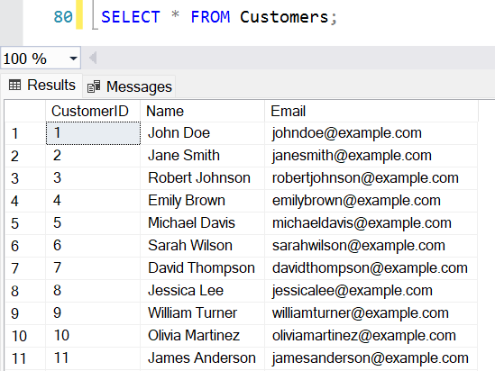

- Write a query to retrieve the names and email addresses of customers whose names start with 'J'.
Ans: SELECT Name, Email
From Customers
Where Name Like 'J%';
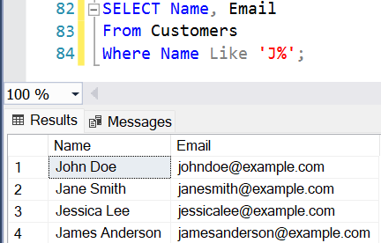

- Write a query to retrieve the order details (OrderID, ProductName, Quantity) for all orders..
Ans: SELECT OrderID, ProductName, Quantity
From Orders;
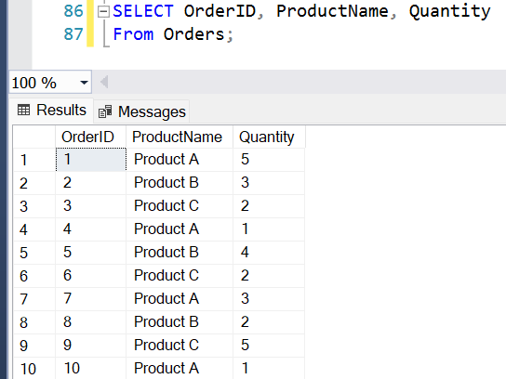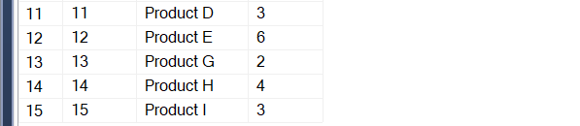

- Write a query to calculate the total quantity of products ordered.
Ans: SELECT SUM(Quantity) as TotalQuantityOrdered
from Orders;
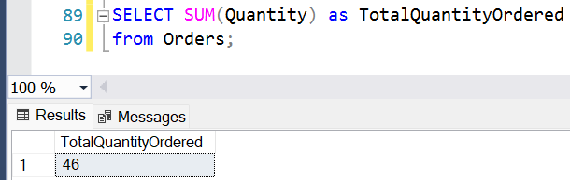

- Write a query to retrieve the names of customers who have placed an order.
Ans: SELECT DISTINCT C.Name
From Customers C
Inner Join Orders O ON C.CustomerID = O.CustomerID;
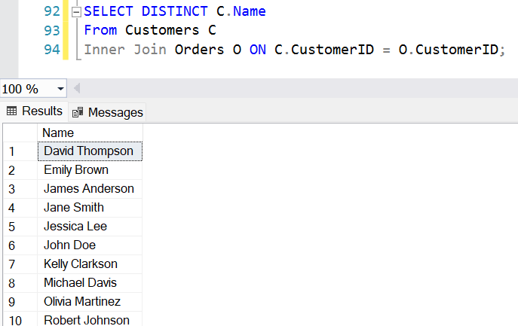

- Write a query to retrieve the products with a price greater than $10.00.
Ans: SELECT ProductID, ProductName, Price
From Products
where Price > 10.00;
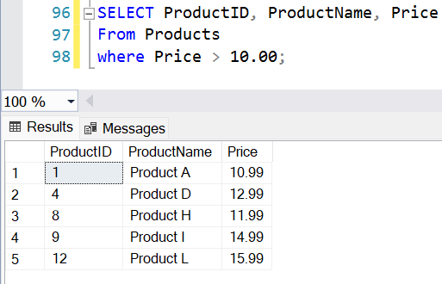

- Write a query to retrieve the customer name and order date for all orders placed on or after '2023-07-05'.
Ans: SELECT C.Name AS CustomerName, O.OrderDate
From Customers C
Inner Join Orders O ON C.CustomerID = O.CustomerID
Where O.OrderDate >= '2023-07-05';
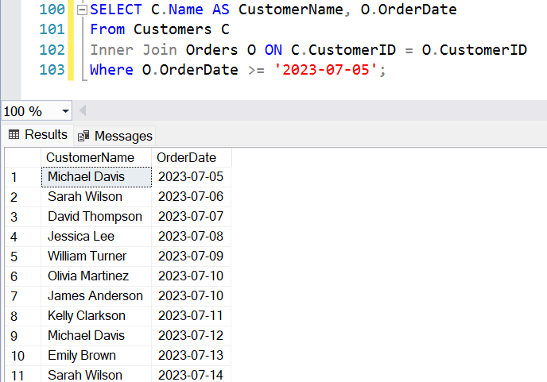

- Write a query to calculate the average price of all products.
Ans: SELECT AVG(Price) AS AveragePrice
From Products;
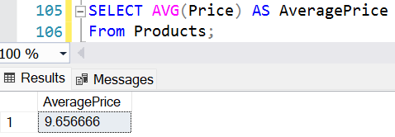

- Write a query to retrieve the customer names along with the total quantity of products they have ordered.
Ans: SELECT C.Name AS CustomerName,
SUM(O.Quantity) AS TotalQuantity
From Customers C
Inner Join Orders O ON C.CustomerID = O.CustomerID
Group By C.Name;
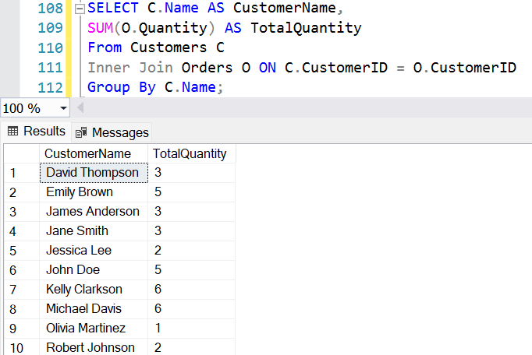

- Write a query to retrieve the products that have not been ordered.
Ans: SELECT P.ProductID, P.ProductName, P.Price
From Products P
Left Join Orders O ON P.ProductName = O.ProductName
Where O.OrderID IS NULL;
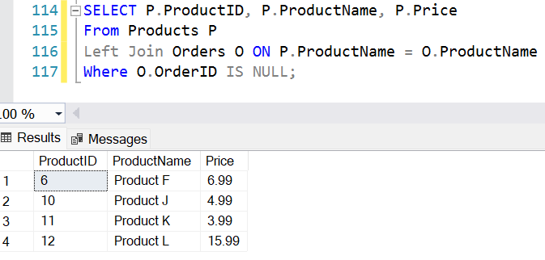

Task 2 :-
- Write a query to retrieve the top 5 customers who have placed the highest total quantity of orders.
Ans: SELECT Top 5 C.Name AS CustomerName,
SUM(O.Quantity) AS TotalQuantity
FROM Customers C
INNER JOIN Orders O ON C.CustomerID = O.CustomerID
GROUP BY C.Name
ORDER BY SUM(O.Quantity) DESC;
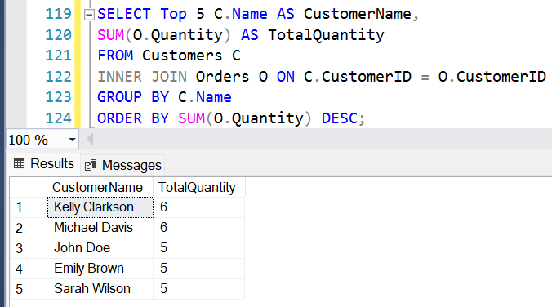

- Write a query to calculate the average price of products for each product category.
Ans: SELECT Category, AVG(Price) AS AveragePrice
FROM Products
GROUP BY Category;
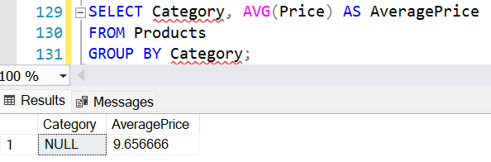

- Write a query to retrieve the customers who have not placed any orders.
Ans: SELECT C.CustomerID, C.Name, C.Email
FROM Customers C
LEFT JOIN Orders O ON C.CustomerID = O.CustomerID
WHERE O.OrderID IS NULL;
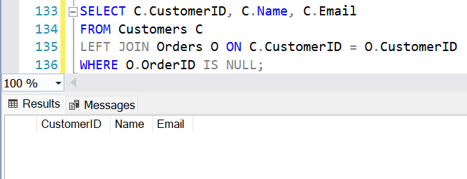

- Write a query to retrieve the order details (OrderID, ProductName, Quantity) for orders placed by customers whose names start with 'M'.
Ans: SELECT C.Name AS CustomerName, O.OrderID, O.ProductName, O.Quantity
FROM Orders O
INNER JOIN Customers C ON O.CustomerID = C.CustomerID
WHERE C.Name LIKE 'M%';
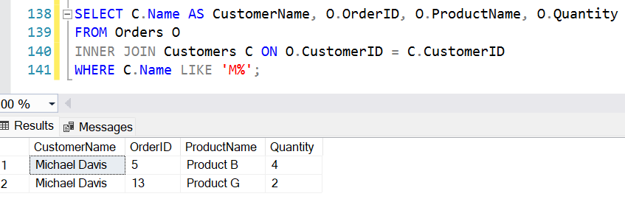

- Write a query to calculate the total revenue generated from all orders.
Ans: SELECT SUM(O.Quantity * P.Price) AS TotalRevenue
FROM Orders O
INNER JOIN Products P ON O.ProductName = P.ProductName;
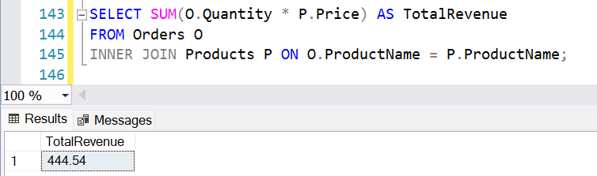

- Write a query to retrieve the customer names along with the total revenue generated from their orders.
Ans: SELECT C.Name AS CustomerName, SUM(O.Quantity *P.Price) AS TotaleRevenue
FROM Customers C
INNER JOIN Orders O ON C.CustomerID = O.CustomerID
INNER JOIN Products P ON O.ProductName = P.ProductName
GROUP BY C.Name
ORDER BY TotaleRevenue DESC;
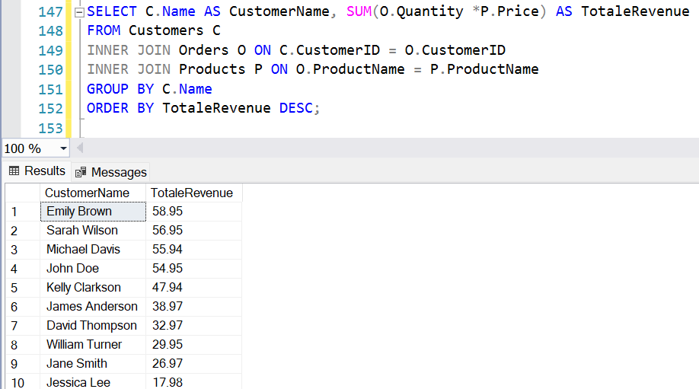
- Write a query to retrieve the customers who have placed at least one order for each product category.
Ans: SELECT C.CustomerID, C.Name
From Customers C
JOIN Orders O ON C.CustomerID = O.CustomerID
JOIN Products P ON O.ProductName = P.ProductName
GROUP BY C.CustomerID, C.Name
HAVING COUNT(DISTINCT P.Category) = (
SELECT COUNT(DISTINCT Category) FROM Products);
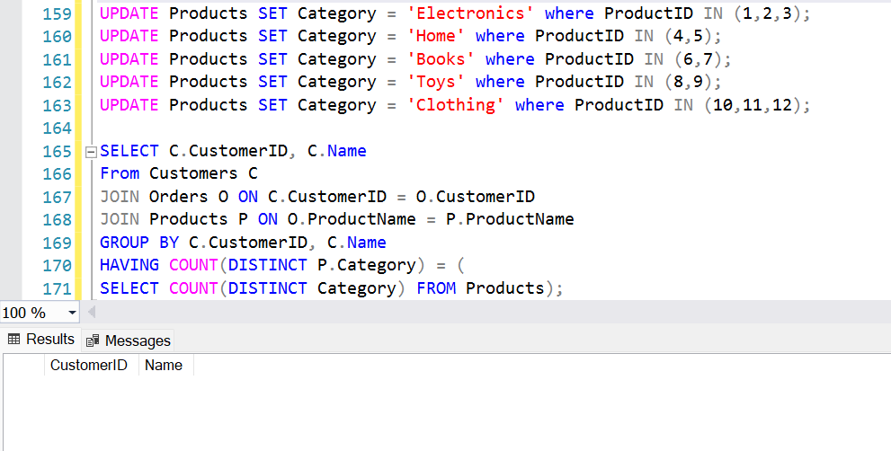

- Write a query to retrieve the customers who have placed orders on consecutive days.
Ans: SELECT Distinct C.CustomerID, C.Name
From Orders O1
JOIN Orders O2
ON O1.CustomerID = O2.CustomerID
AND DATEDIFF(Day, O1.OrderDate, O2.OrderDate) = 1
JOIN Customers C ON O1.CustomerID = C.CustomerID;
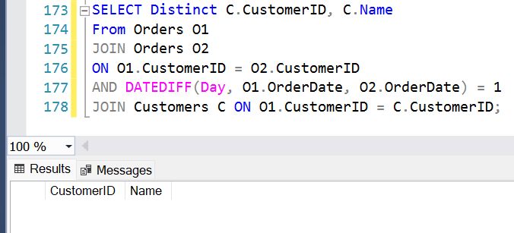

- Write a query to retrieve the top 3 products with the highest average quantity ordered.
Ans: SELECT TOP 3 O.ProductName,
AVG(O.Quantity) AS AvgQuantity
From Orders O
GROUP BY O.ProductName
ORDER BY AVG(O.Quantity) DESC;
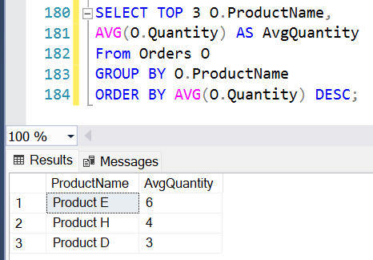

- Write a query to calculate the percentage of orders that have a quantity greater than the average quantity.
Ans: SELECT (CAST(COUNT(*) AS FLOAT) * 100 /
(SELECT COUNT(*) FROM Orders)) AS PercentageAboveAverage
From Orders
WHERE Quantity > (SELECT AVG(Quantity) From Orders);
